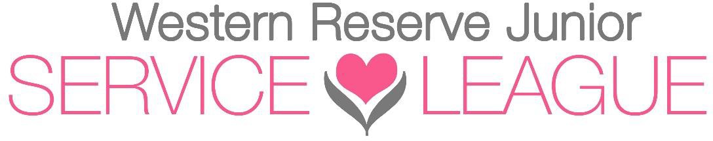

2022 – 2023 Officers

President Carrie Lane

Vice-President Pam Morse

Corresponding Secretary Debbie Kennedy

Recording Secretary Pam Fraser

Treasurer Paula Gordos

2022 – 2023 Board Members

Admissions Carolyn Blackwell & Diana Kokal

Community Research Rita Combs, Debbie Kennedy, Cheryl Kuonen &

Amanda Wayner (Admin)

Endowment Fund Pam Morse & Michelle Haag

Finance Paula Gordos & Ali Wilson

Historian Carrie Lane

Meeting Management Maureen Dolan & Pam Morse

Nominating Lynn Kary

Office Rita Antalovich & Robyn Gattozzi

Past President Ame West

Placement Cheryl Kuonen & Karrie Shannon

Policy & By-Laws Susan Fatica & Vickie McDonald

Provisional Susan Fatica Janet McGee

Public Relations / Social Media Cara Mia Duncan & Ali Wilson

Puppets Sandy Patterson

Ways & Means Jennie Best & Heidi Landgraf

Candlelight Gala Jennie Best & Joanne Miller

Special Placements: Chamber Of Commerce

Eastern Lake County Maureen Dolan

Mentor Carrie Lane

Sustainer Trustees Mary Jo Fryauff & Diana Yount